Xstring is manually added to the project.

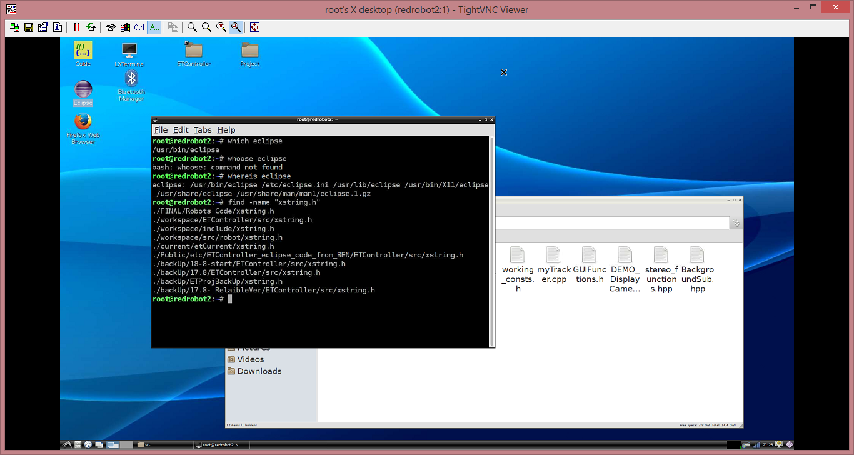

See:

<http://www.umich.edu/~eecs381/handouts/C++11_smart_ptrs.pdf>

also project settings in Eclipse are:

..

Package installations due to VS-linux trial:

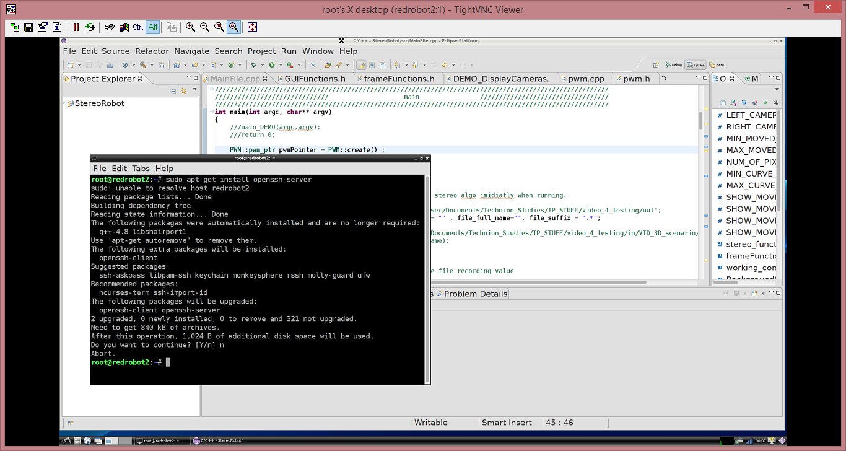

Also

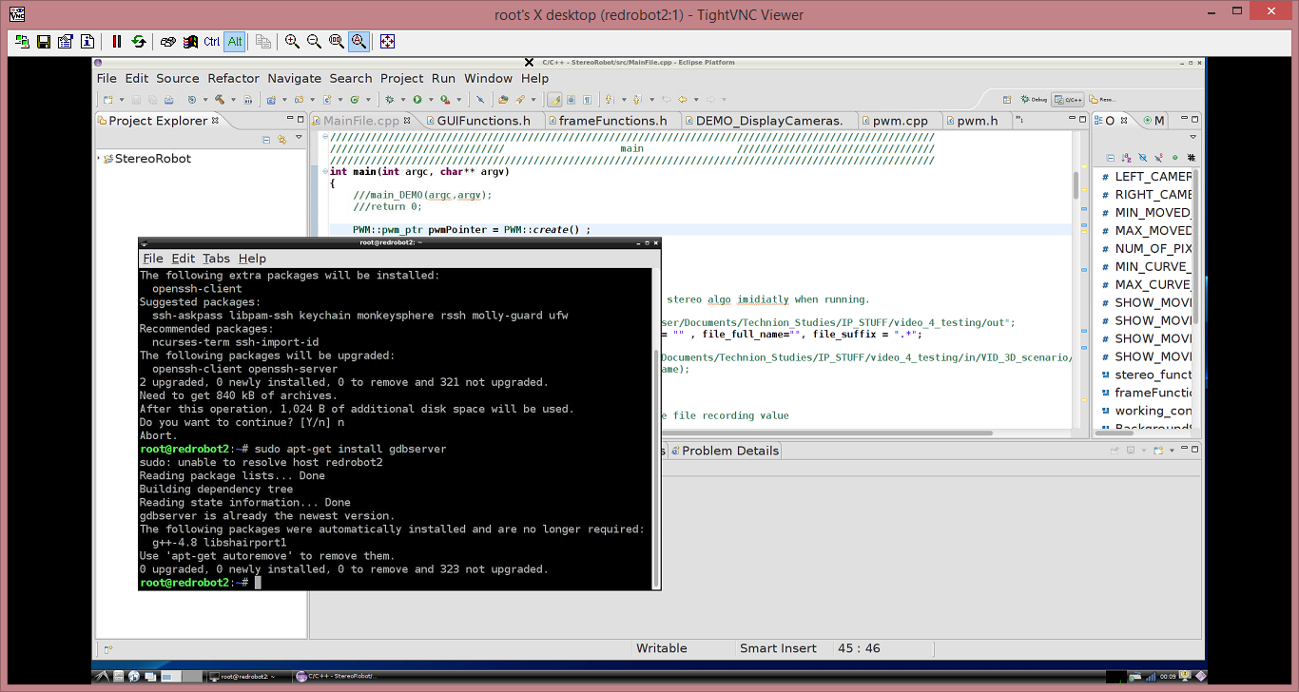

More commands:

modinfo will tell package module information.

According to : <https://help.ubuntu.com/community/SSH/OpenSSH/Configuring>

i just did

sudo restart ssh

I downloaded ‘MobaXterm_v9.1.zip’ to easily verify user and PWD that defined in the system.

(user:root , pwd: as the regular VNC pwd)

Using SSHserver and GDB debugger server for VS2015, also takes time for each compilation to be burned .

Must consider where to compile maybe code-examples, and where the real application.

Examples might be faster from VS. to test threads and such.

Thread notes :

<http://www.bogotobogo.com/cplusplus/multithreaded4_cplusplus11.php>

<https://www.youtube.com/watch?v=f2nMqNj7vxE>